ASSINGNEMENT

**1.**

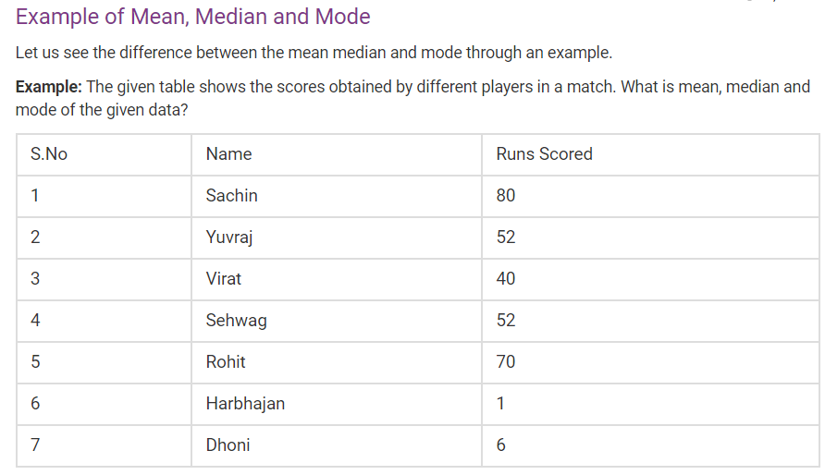

**Mean=** 80+52+40+52+70+1+6/7

=301/7

=43

**Median=** 1 6 40 52 52 70 80

= 52

**Mode=** 52

**2.The points scored by a Kabaddi team in a series of matches are as follows:  
17, 2, 7, 27, 15, 5, 14, 8, 10, 24, 48, 10, 8, 7, 18, 28  
Find the mean, median and mode of the points scored by the team.**

**Mean=** 17+2+7+27+15+5+14+8+10+24+48+10+8+7+18+28/16

=248/16

=15.5

**Median=** 2 5 7 7 8 8 10 10 14 15 17 18 24 27 28 48

= 10+14/2

=24/2 = 12

**Mode=** 7,8,10

**3.**

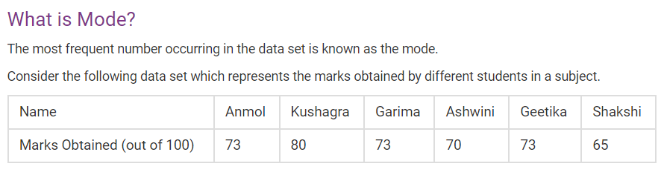

**Mode=** 73

**4. Question:** Find the mean, median, mode and range for the given data:

90, 94, 53, 68, 79, 94, 53, 65, 87, 90, 70, 69, 65, 89, 85, 53, 47, 61, 27, 80

**Mean=** 90+94+53+68+79+94+53+65+87+90+70+69+65+89+85+53+47+61+27+80/20

= 1419/20 = 70.95

**Median=** 27 47 53 53 53 61 65 65 68 69 70 79 80 85 87 89 90 90 94 94

=69+70/2

=139/2 =69.5

**Mode=** 53

**5. Question 1:**Find the mean, median, mode, and range for the following list of values:

13, 18, 13, 14, 13, 16, 14, 21, 13

**Mean=** 13+18+13+14+13+16+14+21+13/9

= 135/9

= 15

**Median=** 13 13 13 13 14 14 16 18 21

= 14

**Mode=** 13